You're working on a new feature for your application. How can you ensure that the feature will not cause a malfunction? And in case it does, how can you revert to the previous version of this application?

It may seem an easy task if you work alone. What if you're a part of a bigger team? Yes, it will be a daunting and cumbersome task. Some developers might use a different library version or a different operating system where the application works for them but doesn't work for others. To avoid it,**Continuous Integration/Continuous Delivery** systems, or CI/CD, step in.

**What is CI/CD?**

The word "continuous" in CI/CD means that everybody on the team commits their code to the single mainline multiple times a day. The "integration" means that before committing, you need to merge with the mainline and make sure everything works fine. The changes done by a developer when the code is committed are tested using an automated process. It creates a build using the submitted code and runs automated tests against the new build. This automation allows developers to routinely release commits without worrying about potential application-breaking code. The automated tests will certainly catch it.

Generally, the following steps happen in CI:

* Lint— to verify the code style;
* Build— to build the application with the feature;
* Test— to ensure you don't break the existing features.

With a proper functioning CI, your code is always merged to the main branch by the pipeline without any human intervention.

The testing is only effective when the tests made by the developer have enough code coverage to isolate the bugs!

A strategy when all the changes are automatically deployed to production after CI is called **delivery**. It facilitates the entire application release process. Continuous delivery is the approach for teams to produce software in short cycles, ensuring that each build is always error-free.

Generally, the following steps happen in CD:

* Test— to ensure you don't break the existing features;
* Release— to put it all together in an easily movable batch;
* Deployment— to make it available to the world.

In CD, the production deployment can either be approved by a person or automatically without explicit approval. The latter is known as **Continuous Deployment**.

There are other continuous processes:

* Continuous documentation: the practice of incrementally developing and updating documentation as part of the development cycle to keep it in sync with the codebase;
* Continuous benchmarking streamlines continuous improvement by focusing on what is happening in the code;
* Continuous testingallows any change made in the code to be tested immediately.

CI/CD automates parts of your project that would otherwise have to be done manually. It finds small issues before they sneak into the main codebase. If your team pushes the bad code out to your customers, you'll end up having a bad week. It also helps prevent something that is called technical debt. The main code repositories are updated over time, so one shortcut fix is always better than an exponentially more expensive fix years later because that fix would be so deeply intertwined into all codebases and logic.

**Benefits of CI/CD**

Continuous integration, delivery, and deployment (CI/CD) have enabled many organizations to release their products on a more frequent basis without compromising on quality. The CI/CD pipeline includes several tools and frameworks to assist developers, testers, and other project participants in delivering software to end users. It increases the overall efficiency of the software delivery process by giving teams more room. Here are some benefits of how CI/CD helps a team of developers:

* CI/CD decreases the deployment time, the speed at which a DevOps team can deliver a functional application to end-users;
* Reduction of delivery risk**,** as you no longer need specialists to ensure the code quality. CI/CD pipeline keeps the code quality in line;
* Changes can be tracked; fast automated feedback is always available;
* CI/CD pipeline can isolate errors making it error-free;
* Easier to rollback, as you can return to the previous code version if any problem occurs.

**Popular CI/CD environments**

There are a lot of CI/CD solutions, so let's look at the most popular ones:

* Jenkins— is a self-hosted setup. It is an open-source CI server for automating the build and testing processes. It is very flexible as it provides numerous plugins across multiple platforms to improve performance.
* Team City— is very robust as it provides real-time reporting when a test fails. It also pinpoints the exact commits that caused the test to fail.
* GitHub Actions— is a cloud-based setup. It enables us to automate our workflows easily. You can directly build, test, and deploy the code right from GitHub. It also makes it easier to carry out code reviews and manage branches.
* GitLab— is simple to set up as a self-hosted GitHub alternative. It has better documentation and is much easier to use with containerized builds.

**Conclusion**

CI/CD deals with how software is continuously written, integrated, analyzed, and deployed to customers. CI/CD helps test new code to ensure seamless logic and format of the code. It also assists with fulfilling the scope of the project. CI/CD means faster speed in the marketplace and higher quality code, limiting the fears of technical debt.

Read more on this topic in [Bridging the Gap by Understanding DevOps](https://hyperskill.org/blog/post/bridging-the-gap-between-development-and-operations-by-understanding-devops) on Hyperskill Blog.

## Choose the right build

What kind of build do we usually deploy to a production environment?

Select one option from the list

**Release build**

### Explanation:

A **Release build** is optimized, tested, and configured for deployment to a **production environment**. It typically excludes debugging information and includes performance enhancements, making it suitable for end users.

On what type of process do CI/CD pipelines mostly rely upon? Automatic

What is the flow of the CI/CD pipeline?

Here is the correct flow of a typical **CI/CD pipeline**:

1. **Code** – Developers write and commit code to the version control system.
2. **Build** – The code is compiled and dependencies are resolved.
3. **Test** – Automated tests (unit, integration, etc.) are run to ensure code quality.
4. **Release** – The code is packaged and prepared for deployment.
5. **Deploy** – The application is deployed to a staging or production environment.

✅ **Final Order**:  
**Code → Build → Test → Release → Deploy**

What steps are involved in Continuous Integration?

The correct steps involved in **Continuous Integration (CI)** typically include:

✅ **Test**  
✅ **Lint**  
✅ **Build**

❌ **Release** – This is usually part of **Continuous Deployment/Delivery (CD)**, not CI.

**Explanation:**

* **Lint**: Checks code quality and formatting.
* **Build**: Compiles code or prepares artifacts.
* **Test**: Runs automated tests to validate functionality.
* **Release**: Comes after CI in the CD pipeline.

Which is not a CI practice?

he correct answer is:

❌ **Production deployment**

**Explanation:**

* **Production deployment** is part of **Continuous Deployment (CD)**, **not** Continuous Integration (CI).
* **CI practices** include:
  + ✅ **Commits frequently**
  + ✅ **Stage builds**
  + ✅ **Runs fast builds**

## Choose the right definition

What describes how continuous delivery works in the best way?

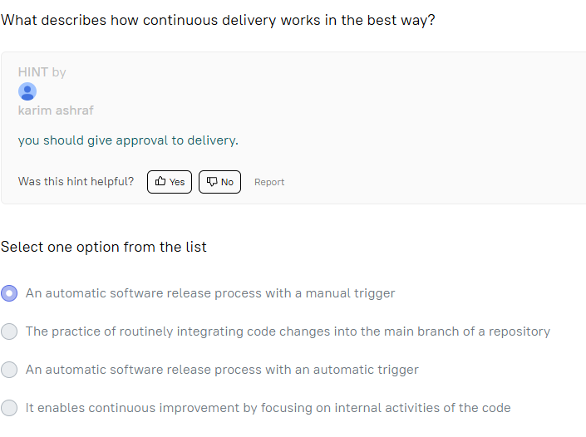**An automatic software release process with a manual trigger**

### Explanation:

**Continuous Delivery (CD)** is the practice of ensuring that code is always in a deployable state. The release process is **automated**, but the **actual deployment to production requires manual approval** — this aligns with the hint: "you should give approval to delivery."

What are the benefits of CI/CD?

The correct answers are:

✅ **Faster bug fixes**  
✅ **Decreases deployment time**  
✅ **Tighter feedback**  
✅ **Easier rollback**

### Explanation:

* **Faster bug fixes**: CI/CD enables rapid detection and correction of issues.
* **Decreases deployment time**: Automation reduces manual steps and speeds up delivery.
* **Tighter feedback**: Frequent integration and testing provide immediate feedback to developers.
* **Easier rollback**: Versioning and automated deployments make it simpler to revert to a stable state.

❌ **"Continuous change does not require continuous monitoring and reporting"** is **incorrect** — monitoring and reporting are essential in CI/CD to ensure quality and stability.